**Write queries (5 points each) against the Sakila database to answer the following requests:**

1. How many distinct countries are there?

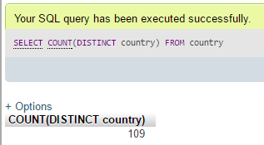

1. Find out the top 5 countries with most number of clients.

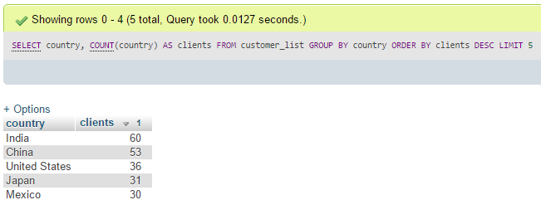

1. What are the names of all the languages in the database (sorted alphabetically)?

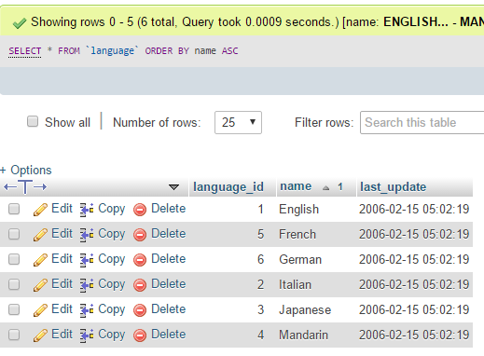

1. Return the full names (first and last) of actors with “SON” in their last name, ordered by their first name.

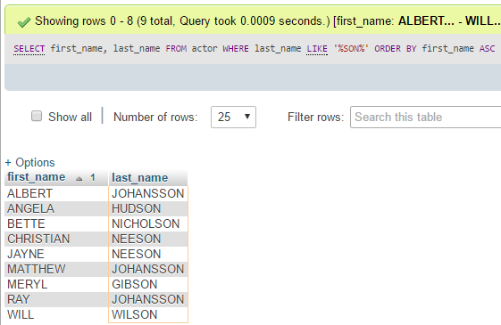

1. Create a list of films and their corresponding categories.

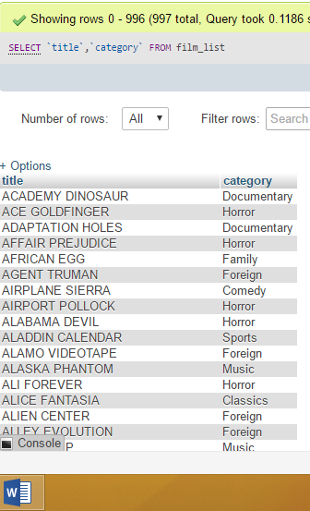

1. Create a list of categories and the number of films for each category.

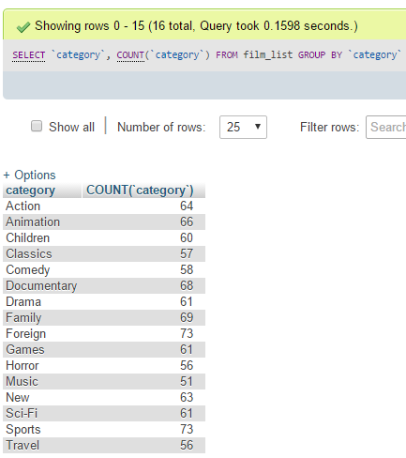

1. Create a list of actors and the number of movies by each actor.

[SELECT](http://127.0.0.1:81/phpmyadmin/url.php?url=https://dev.mysql.com/doc/refman/5.5/en/select.html) actor.first_name,actor.last_name,[COUNT](http://127.0.0.1:81/phpmyadmin/url.php?url=https://dev.mysql.com/doc/refman/5.5/en/group-by-functions.html#function_count)(film_actor.actor_id) AS movies

FROM film_actor JOIN actor

ON film_actor.actor_id=actor.actor_id

GROUP BY film_actor.actor_id

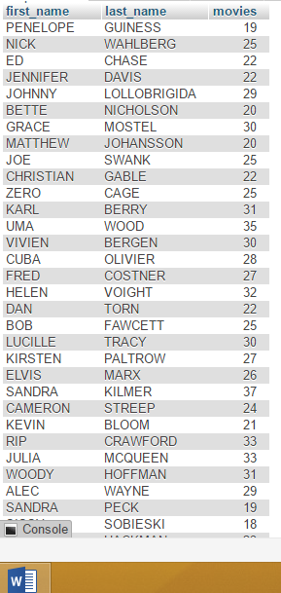

1. Find the number of English films in the category of ‘Documentary’

[SELECT](http://127.0.0.1:81/phpmyadmin/url.php?url=https://dev.mysql.com/doc/refman/5.5/en/select.html) [COUNT](http://127.0.0.1:81/phpmyadmin/url.php?url=https://dev.mysql.com/doc/refman/5.5/en/group-by-functions.html#function_count)(*) FROM `film`

JOIN language ON film.language_id=language.language_id

JOIN film_category ON film_category.film_id=film.film_id

JOIN category ONcategory.category_id=film_category.category_id

WHERE language.name='English'[AND](http://127.0.0.1:81/phpmyadmin/url.php?url=https://dev.mysql.com/doc/refman/5.5/en/logical-operators.html#operator_and) category.name='Documentary'

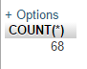

1. How many actors have not acted in any films?

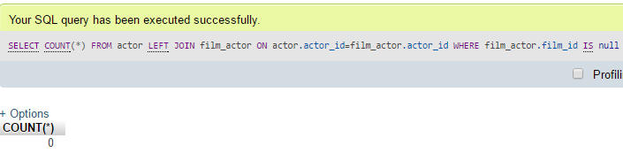

1. How many films are out on rent?

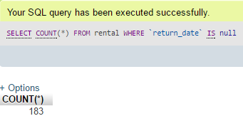

1. What is the most common hour when people pay for a dvd rental?

[SELECT](http://127.0.0.1:81/phpmyadmin/url.php?url=https://dev.mysql.com/doc/refman/5.5/en/select.html) hour AS Most_Common_Hour, [COUNT](http://127.0.0.1:81/phpmyadmin/url.php?url=https://dev.mysql.com/doc/refman/5.5/en/group-by-functions.html#function_count)(hour)AS freq

FROM ([SELECT](http://127.0.0.1:81/phpmyadmin/url.php?url=https://dev.mysql.com/doc/refman/5.5/en/select.html) EXTRACT(HOUR FROM `payment_date`)AS hour FROM `payment`) AS hours

GROUP BY hour ORDER BY freq DESC LIMIT 1

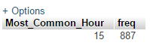

1. Which actors have the first name ‘Scarlett’?

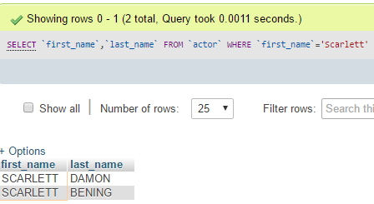

1. Which actors have the last name ‘Johansson’

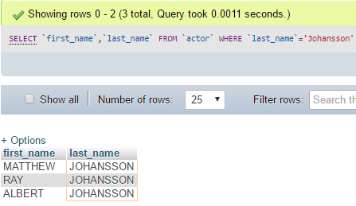

1. How many distinct actors last names are there?

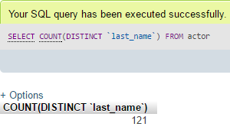

1. Which last names are not repeated?

[SELECT](http://127.0.0.1:81/phpmyadmin/url.php?url=https://dev.mysql.com/doc/refman/5.5/en/select.html) last_name FROM

([SELECT](http://127.0.0.1:81/phpmyadmin/url.php?url=https://dev.mysql.com/doc/refman/5.5/en/select.html) last_name,[COUNT](http://127.0.0.1:81/phpmyadmin/url.php?url=https://dev.mysql.com/doc/refman/5.5/en/group-by-functions.html#function_count)(last_name)AS times FROM actor GROUP BY last_name)AS last_names WHERE times=1

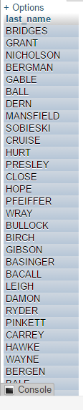

1. Which last names appear more than once?

[SELECT](http://127.0.0.1:81/phpmyadmin/url.php?url=https://dev.mysql.com/doc/refman/5.5/en/select.html) last_name FROM ([SELECT](http://127.0.0.1:81/phpmyadmin/url.php?url=https://dev.mysql.com/doc/refman/5.5/en/select.html) last_name,[COUNT](http://127.0.0.1:81/phpmyadmin/url.php?url=https://dev.mysql.com/doc/refman/5.5/en/group-by-functions.html#function_count)(last_name)AS times FROM actor GROUP BY last_name)AS last_names WHERE times>1

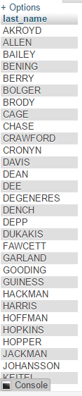

1. Which actor has appeared in the most films?

[SELECT](http://127.0.0.1:81/phpmyadmin/url.php?url=https://dev.mysql.com/doc/refman/5.5/en/select.html) actor.first_name,actor.last_name,[COUNT](http://127.0.0.1:81/phpmyadmin/url.php?url=https://dev.mysql.com/doc/refman/5.5/en/group-by-functions.html#function_count)(film_actor.actor_id)AS appeared FROM film_actor JOIN actor ON actor.actor_id=film_actor.actor_id GROUP BY film_actor.actor_id ORDER BY appeared DESC LIMIT 1



1. When is ‘Academy Dinosaur’ due?

[select](http://127.0.0.1:81/phpmyadmin/url.php?url=https://dev.mysql.com/doc/refman/5.5/en/select.html) rental_date, rental_date + [interval](http://127.0.0.1:81/phpmyadmin/url.php?url=https://dev.mysql.com/doc/refman/5.5/en/comparison-operators.html#function_interval) ([select](http://127.0.0.1:81/phpmyadmin/url.php?url=https://dev.mysql.com/doc/refman/5.5/en/select.html) rental_duration from film where film_id = 1) day as due_date from rental where rental_id = ([select](http://127.0.0.1:81/phpmyadmin/url.php?url=https://dev.mysql.com/doc/refman/5.5/en/select.html) rental_id from rental order byrental_id desc limit 1)



1. What is that average running time of all the films in the sakila DB?

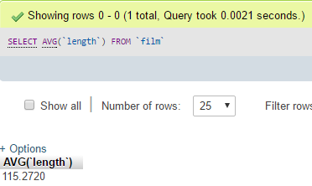

1. What is the average running time of films by category?

[select](http://127.0.0.1:81/phpmyadmin/url.php?url=https://dev.mysql.com/doc/refman/5.5/en/select.html) category.name, [avg](http://127.0.0.1:81/phpmyadmin/url.php?url=https://dev.mysql.com/doc/refman/5.5/en/group-by-functions.html#function_avg)(length) from film

join film_category using (film_id)

join category using (category_id) group by category.name

